Power BI
Project Report
on

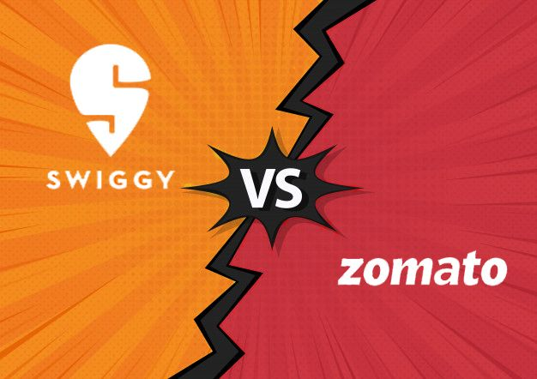

COMPARATIVE ANALYSIS OF ZOMATO AND SWIGGY BASED ON CUNSUMER PERCEPTION

SUBMITTED TO: Elevate Labs
SUBMITTED BY: Charul Manishi

Project Overview:
This report provides a comparative analysis of two leading food delivery platforms in India — Swiggy and Zomato — based on data visualized in a Power BI dashboard. The comparison is based on metrics like Order ID, Platform, City, Restaurant, Cuisine, Order Value, Delivery Time, Customer Rating, Order Hour, Order Day and customer preferences in metropolitan cities like Delhi, Kolkata, Pune, Bengaluru, Mumbai, Hyderabad, Chennai, etc.

Tools and Technologies:
Power BI: For creating interactive dashboards and visualizations.
SQL: To query and manipulate data from the bookings dataset.
Microsoft Excel: For initial data cleaning and preprocessing.

Outcome:
Interactive Dashboard - a comprehensive Power BI dashboard showcasing key metrics and trends.

Observations:
- Swiggy leads slightly in orders, revenue, and restaurant partnerships.
- Zomato performs marginally better in delivery speed.
- User ratings are nearly identical, indicating equal satisfaction

Data-Driven Insights:
- Swiggy leads slightly in total orders, revenue, and partner restaurants.
- Zomato has a marginally faster average delivery time.
- Ratings are nearly the same, indicating similar user satisfaction.

Order Distribution by Time:
Both platforms show high activity in:
- Late morning to afternoon (10 AM - 3 PM)
- Evening peak hours (6 PM - 10 PM)
This indicates common meal-time ordering trends across both cities.

Insights:
- Zomato sees more weekend activity, possibly reflecting higher leisure-based ordering.
- Swiggy maintains a more balanced weekday/weekend split.
- Cuisine preferences are regionally diverse, supporting the need for localized menu strategies.
- Both platforms are neck-and-neck in user satisfaction, as reflected in comparable ratings.

Conclusion:
Both Swiggy and Zomato are performing competitively with minor differences across metrics. Swiggy holds a slight edge in terms of order volume and revenue, while Zomato shows faster delivery and higher weekend engagement. Consumer cuisine preferences vary slightly by region, offering room for hyper-local marketing and menu optimization.

Recommendations:
- Swiggy could leverage its weekday strength by promoting weekday lunch combos and corporate partnerships.
- Zomato might enhance weekday performance with loyalty programs or subscription models.
- Both can explore hyper-personalized recommendations using cuisine popularity data.

OUTPUT SCREENSHOT (DASHBOARD)

